**Geometric Proofs:**

Don’t forget Q.E.D when done

To prove something, we must present evidence to convince others of the truth of the statement

Axions:

Statements that are simply accepted as being true without the need of proof

Theorems:

Are statements that can be proved to be true using accepted deffinions, axions and other (proved_ theorems

Definition:

Due to how they are defined

e.g. of proofs

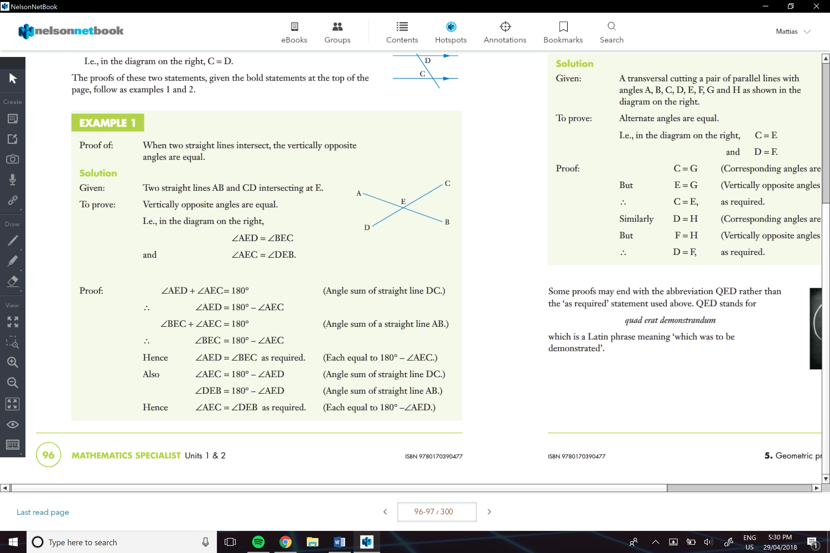

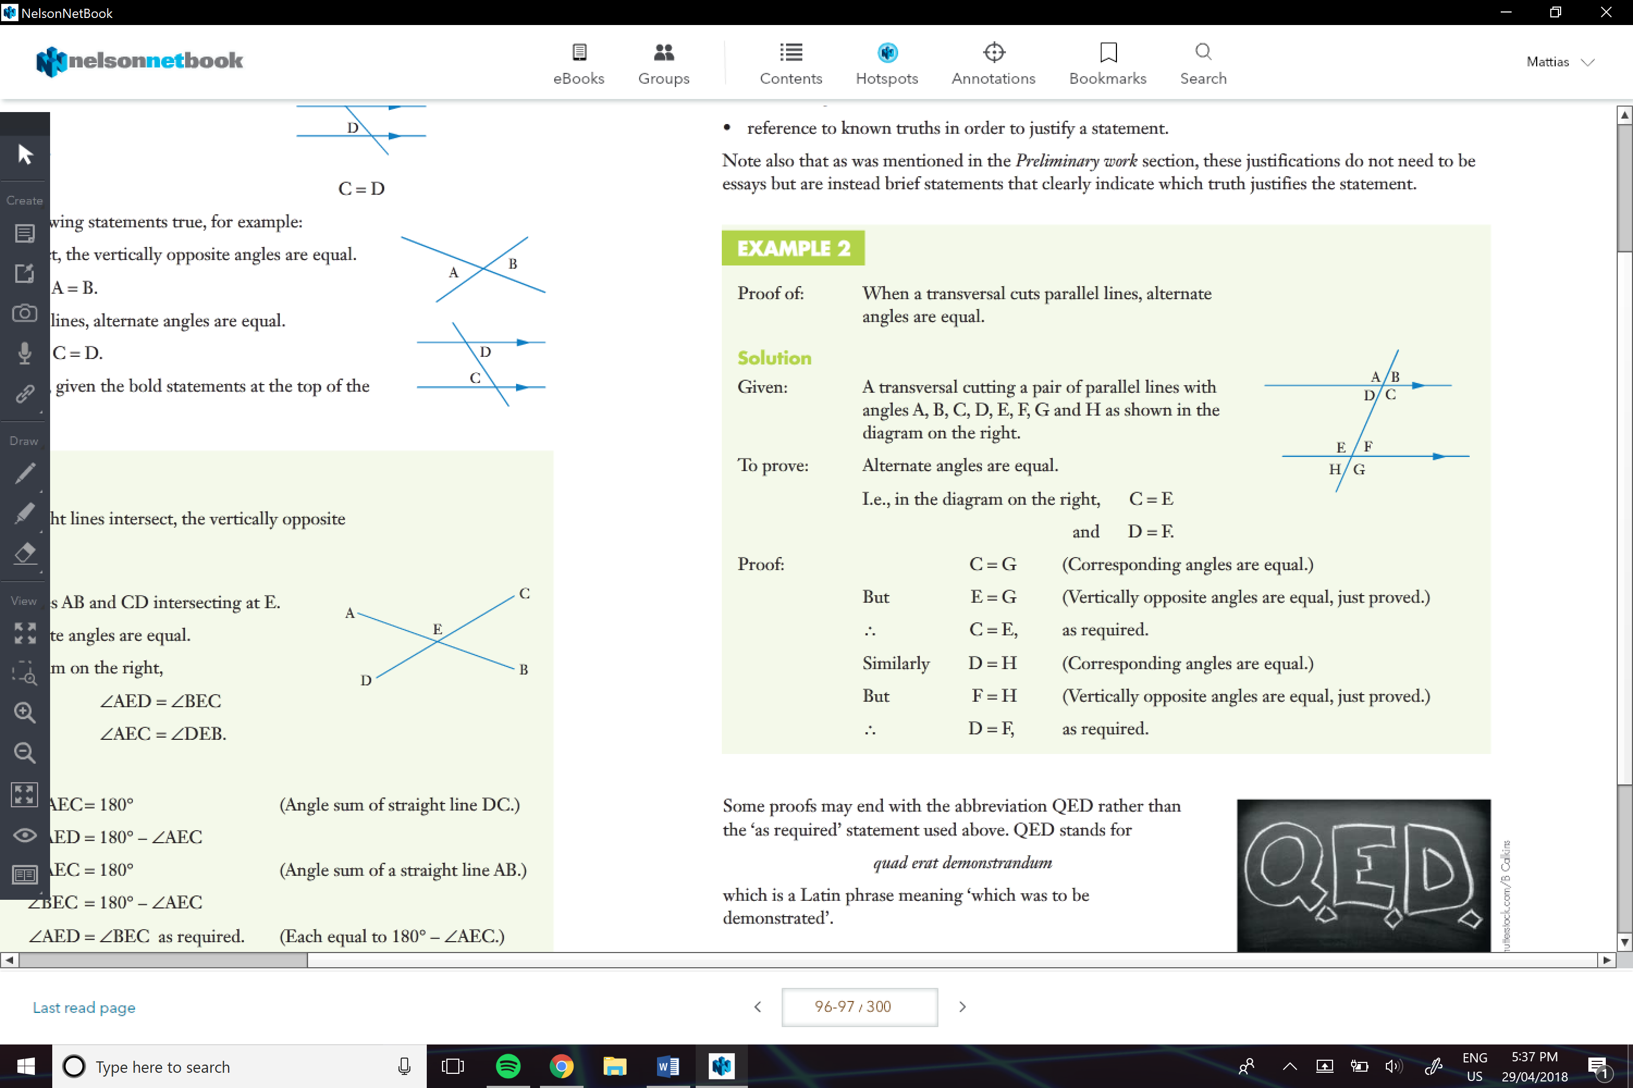

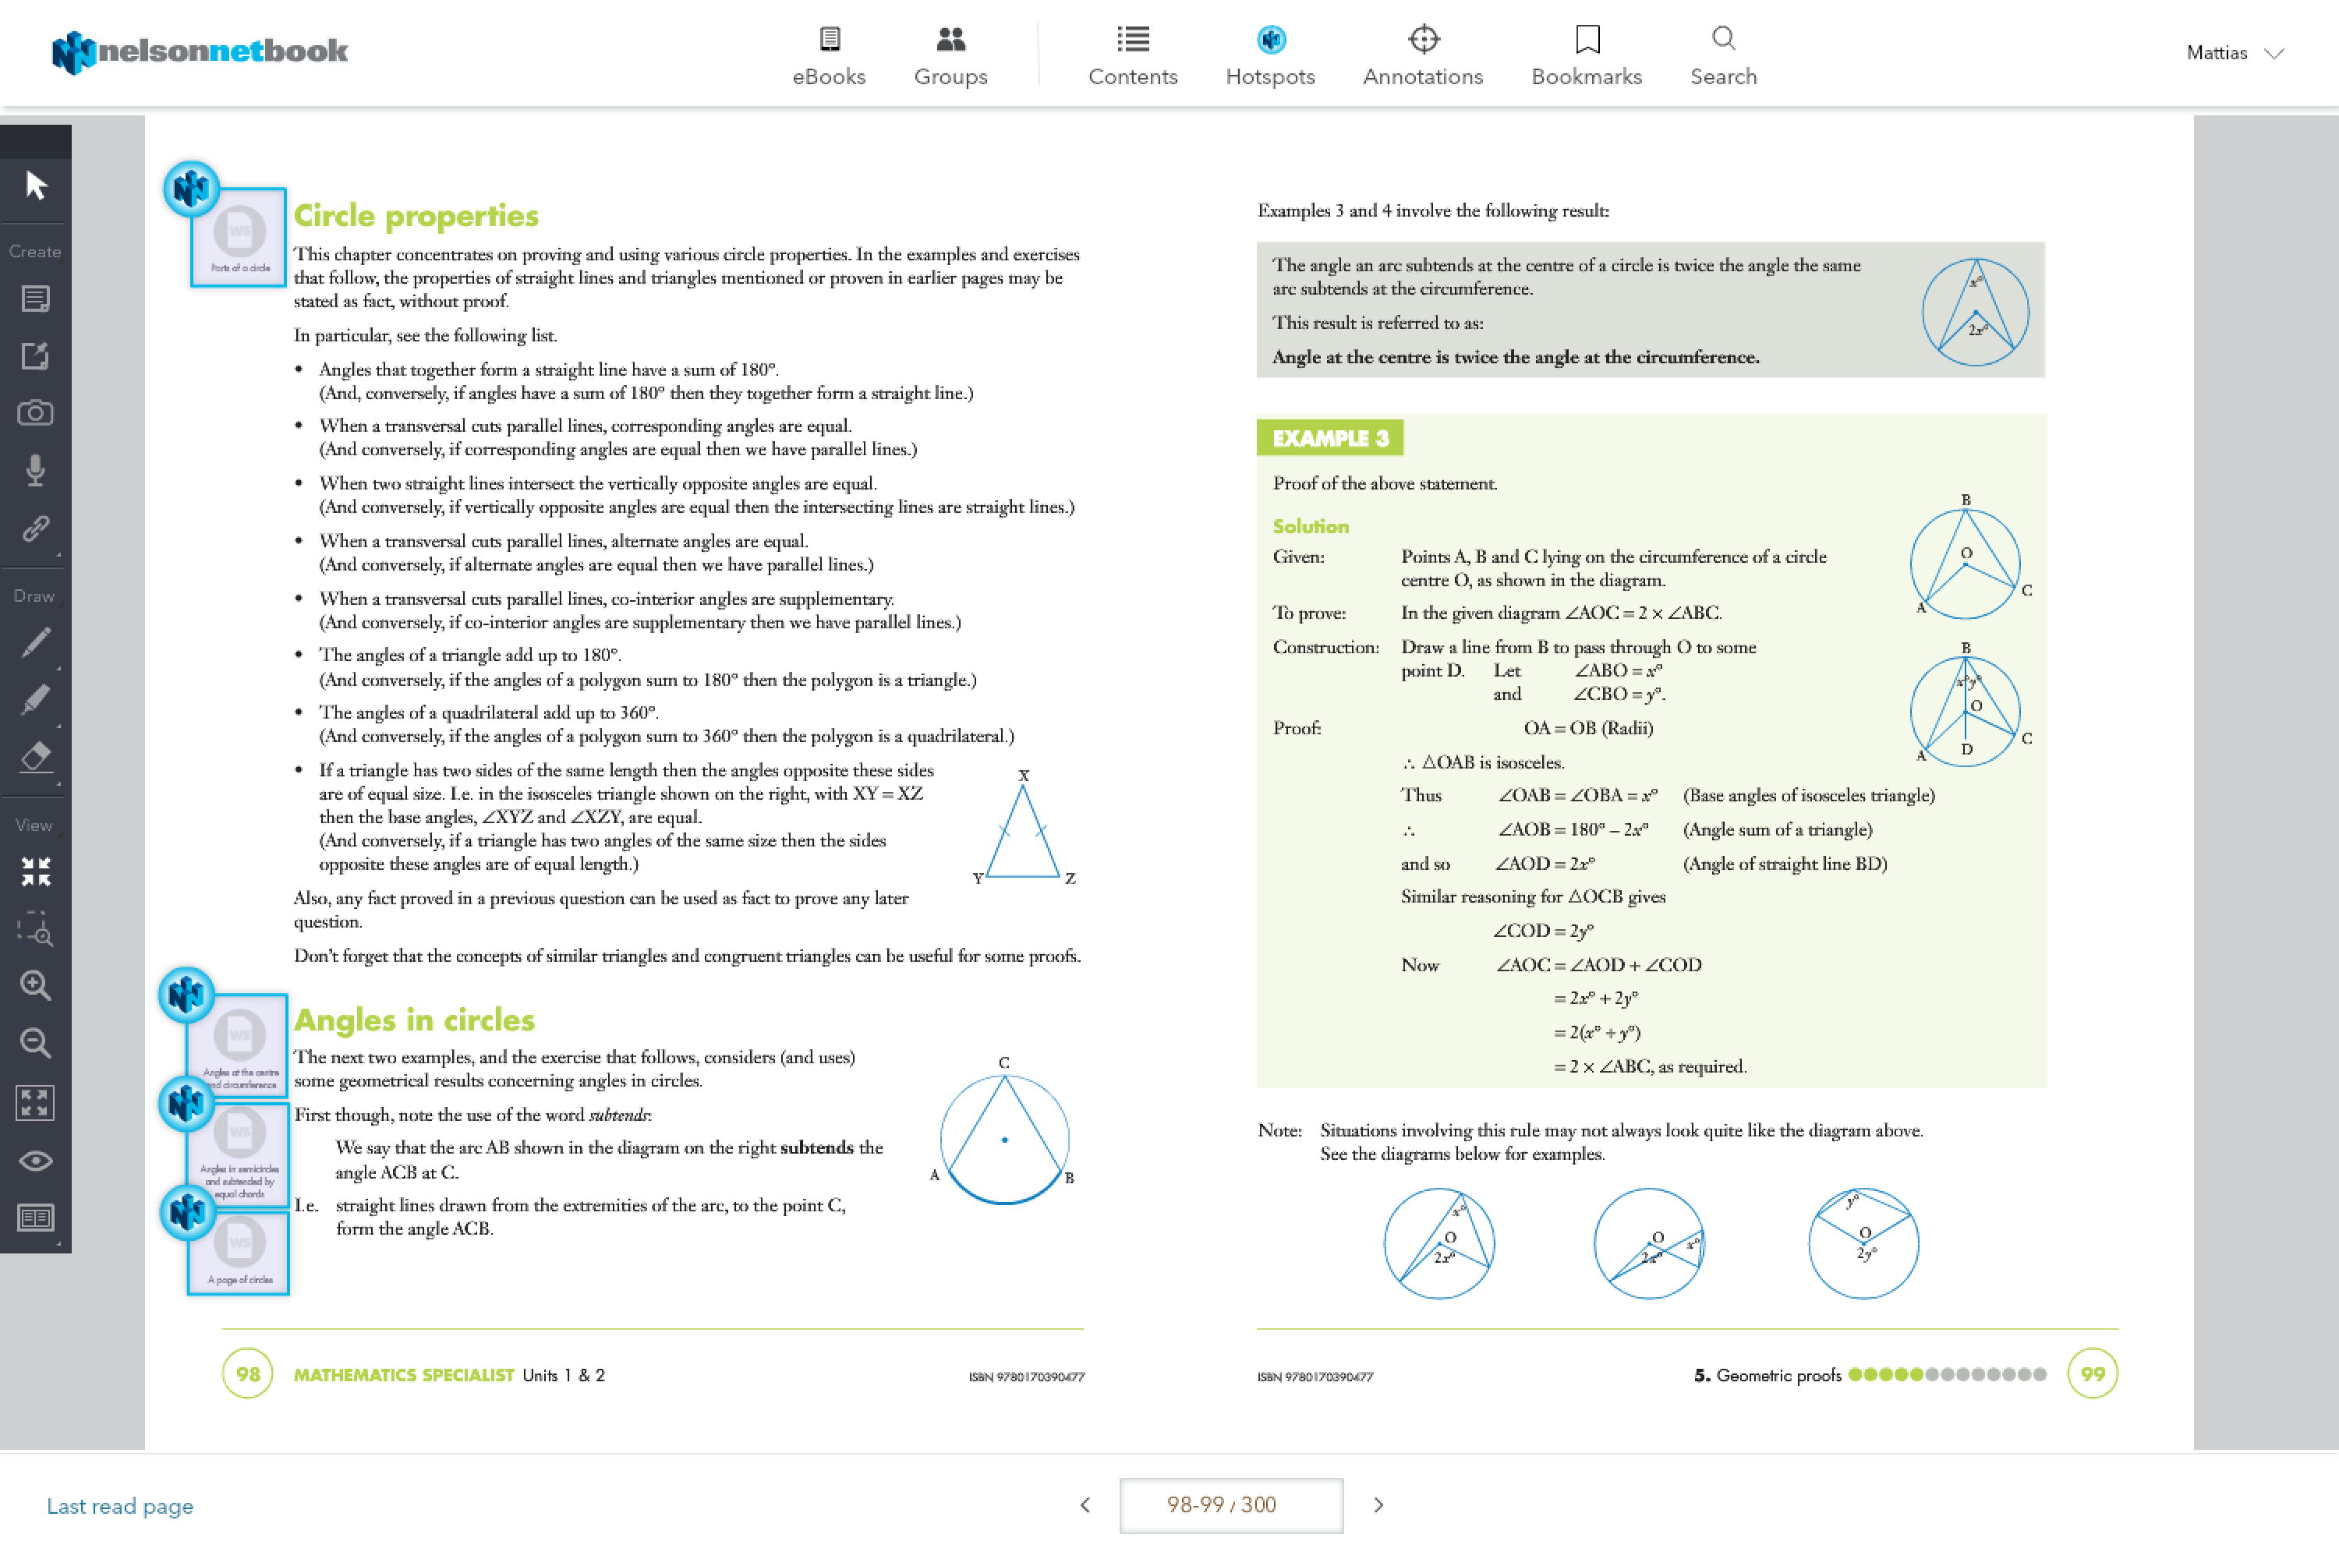

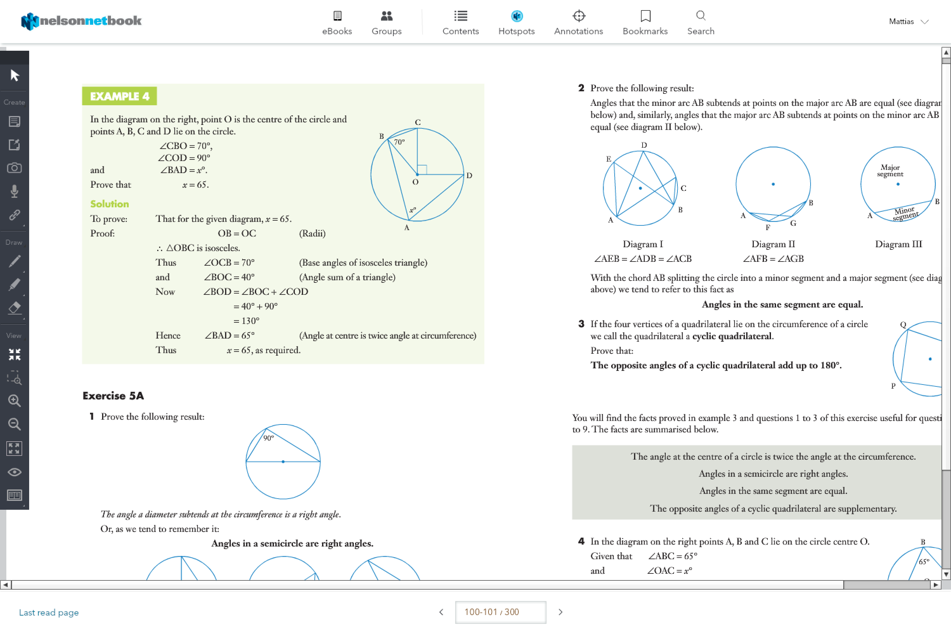

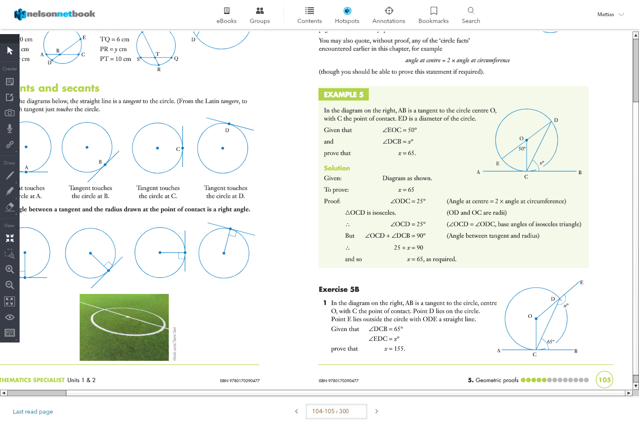

In summary…

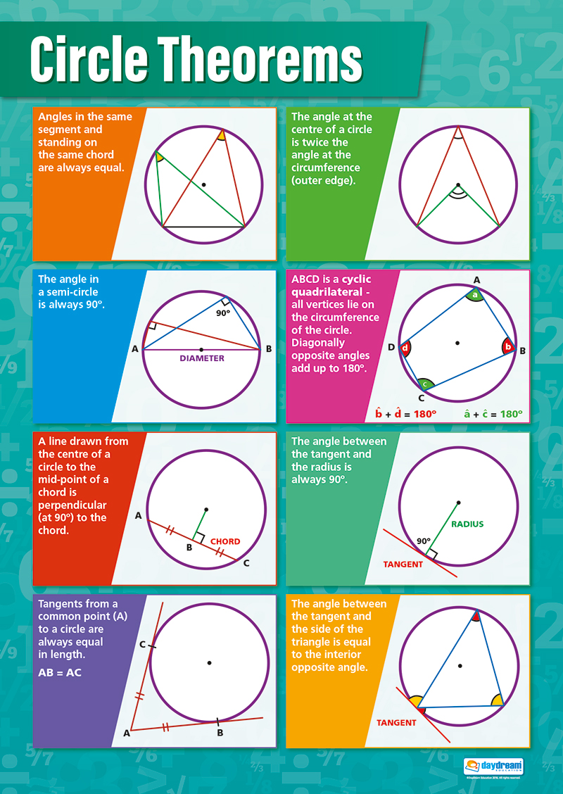

**Similar Triangles:**

AA

SAS

AAA

SSS

Hyp and S…